

**KARATINA UNIVERSITY**

**SCHOOL OF PURE AND APPLIED SCIENCES**

**DEPARTMENT OF COMPUTER SCIENCE AND INFORMATICS**

**PROJECT TITLE:**

**PREDICTING THE PRICES OF CRYPTOCURRENCIES USING LONG SHORT-**

**TERM MEMORY NEURAL NETWORK.**

**BY:**

**GAVIN WACIRA NJOROGE.**

**P101/1374G/20**

**PROJECT REPORT SUBMITTED TO THE SCHOOL OF PURE AND APPLIED SCIENCES IN PARTIAL FULFILLMENT OF THE REQUIREMENT FOR THE AWARD OF THE DEGREE IN BACHELOR OF SCIENCE IN COMPUTER SCIENCE**

**MAY 3, 202**

# DECLARATION

I declare that this Project Proposal is my original work and has not been previously published

or submitted elsewhere for award of a degree. I also declare that this contains no material

written or published by other people except where due reference is made and author duly

acknowledged.

STUDENT NAME: ____________________________REG NO: ____________________

SIGN: ____________________________ DATE: _____________________________

**SUPERVISOR**

I the undersigned do hereby certify that this is a true report for the project undertaken by the above named student under my supervision and that it has been submitted to Karatina University with my approval

Signature…………………………………………………….Date…………………………….

# DEDICATION

I dedicate this work to the Almighty God for His grace, mercy, and guidance. To the lecturers at Karatina University, thank you for imparting knowledge and shaping my academic path. My heartfelt gratitude goes to my parents for their unwavering support and sacrifices for my education I really do not take anything for granted, Thank you Mum and Dad. Karatina University, thank you for providing a conducive learning environment. This work reflects the values instilled in me by my family and the knowledge imparted by my lecturers. I dedicate this to all of you with love and gratitude.

# ABSTRACT

Cryptocurrency markets, fueled by blockchain technology, have significantly transformed the global financial landscape since Bitcoin's emergence in 2009. As a critical asset class and trading avenue, cryptocurrencies remain vulnerable to challenges such as price volatility and regulatory ambiguities. This study harnesses the power of Long Short-Term Memory (LSTM) neural networks and technical indicators, including Exponential Moving Average (EMA) and Relative Strength Index (RSI), to predict cryptocurrency prices over the next decade. The primary objectives encompass an in-depth analysis of historical price data, exploration of LSTM-based model impact on prediction accuracy. By optimizing these components, this project seeks to to forecast price movements, thereby contributing to a more stable and informed investment within the world of cryptocurrencies.

# ACKNOWLEDGEMENTS

I would like to thank everyone who has contributed to the successful completion of this project. I would like to express my gratitude to my research supervisor, Dr. Paul Kariuki  for his invaluable advice, guidance and his enormous patience throughout the development of the research project. In addition, I would also like to express my gratitude to my loving parent and friends who had helped and given me encouragement.

# TABLE OF CONTENTS

# CHAPTER ONE: INTRODUCTION

* 1. **Introduction**

In the dynamic realm of cryptocurrency, an innovative endeavor emerged, aiming to revolutionize the way we forecasted market trends. Powered by the Long Short-Term Memory (LSTM) neural network and bolstered by technical indicators such as Exponential Moving Average (EMA) and Relative Strength Index (RSI), this project set its sights on taming the volatile nature of digital assets.

The LSTM neural network, an adaptable framework for sequential data processing, sat at the heart of this initiative. LSTM's capability to capture intricate patterns from historical prices set the stage for precise trend predictions. When integrated with the momentum-based insights of EMA and the overbought/oversold signals from RSI, this triad of predictive power elevated market analysis to unprecedented levels.

However, the project's vision extended beyond technological prowess. It sought to empower investors with a reliable decision-making tool in the high-stakes world of cryptocurrency trading. Accurate forecasts paved the way for informed investments, minimizing risk exposure while maximizing potential returns. Furthermore, the initiative contributed to a more stable investment landscape, fostering a sense of confidence among market participants.

**1.2 Background of the Study**

In the ever-evolving financial landscape, cryptocurrency arose as a game-changing phenomenon following the advent of Bitcoin in 2009. Operating on blockchain technology, a decentralized digital ledger system, cryptocurrencies offered heightened security and privacy while eliminating intermediaries. Despite their innovative nature, cryptocurrencies confronted challenges such as price volatility, regulatory uncertainties, speculation on fraudulent activity, and environmental concerns due to energy-intensive mining.

Bitcoin, the pioneering cryptocurrency, epitomized the market's potential for substantial gains and losses, demonstrating significant price fluctuations over the years. The value of one Bitcoin soared from \$357.24 in November 2015 to \$19,891.99 in December 2017, only to plummet to \$11,509.31 in October 2020, and then dramatically rise again to \$30,220.42 in April 2023. This rollercoaster ride of value shifts underscored the need for investors to employ advanced strategies, including machine learning (ML) algorithms, to predict prices and navigate the volatile cryptocurrency market effectively. These algorithms dissected historical data, revealing patterns and trends, ultimately empowering investors to make informed decisions.

**1.3 Problem Statement**

The volatile nature of the cryptocurrency market posed significant challenges for investors seeking accurate price predictions. Although machine learning algorithms held promise, there was a critical gap in long-term forecasting methods, particularly those employing Long Short-term Memory (LSTM) neural networks. Additionally, the underutilization of technical indicators such as Exponential Moving Average (EMA), Relative Strength Index (RSI), and Simple Moving Average (SMA) as input features remained underexplored, further hindering the potential for accurate predictions.

In the absence of robust predictive models accounting for long-term trends and incorporating relevant indicators, investors faced heightened uncertainty and risk in their decision-making processes, which could have led to financial losses. Addressing these gaps was essential for improving predictive accuracy and enabling informed investment decisions within the volatile cryptocurrency market.

**1.4 Objectives**

**1.4.1 General Objective**

The main objective of this study was to predict prices of cryptocurrencies in the next decade using long short-term memory neural network.

**1.4.2 Specific Objectives**

1. To analyze the patterns within historical cryptocurrency price data obtained from reliable sources.
2. To recommend the adoption of an LSTM-based prediction model for forecasting cryptocurrency prices.
3. To evaluate the contribution of technical indicators to the predictive accuracy of the LSTM model.
4. To interpret the findings to facilitate informed decision-making in investments.

**1.5 Scope and Limitation of the Study**

The scope of this study was primarily focused on predicting cryptocurrency prices over the next decade using Long Short-Term Memory (LSTM) neural networks. Despite the comprehensive scope, this study faced certain limitations. The reliance on historical data may not entirely capture future market behavior, given the rapidly evolving nature of cryptocurrencies. Additionally, the focus on specific technical indicators might overlook other potentially influential factors affecting price movements. The study's retrospective analysis may not fully account for real-time market dynamics, and the generalizability of findings may be subject to regional variations and changing regulatory environments. Lastly, the study's predictive model primarily served as a guidance tool, with actual investment decisions still requiring human discretion and judgement.

**1.6 Justification**

Conducting this project held immense potential to revolutionize cryptocurrency trading and investment by developing an accurate prediction model using advanced machine learning techniques, particularly Long Short-Term Memory (LSTM) neural networks. Accurate cryptocurrency price prediction was paramount for informed investment decisions in this rapidly evolving market. Given the high volatility and unpredictability of cryptocurrency markets, this research provided valuable insights to investors, enabling them to make informed decisions, devise risk mitigation strategies, and maximize returns on investment.

Moreover, this project aimed to address the gap in the application of LSTM neural networks in cryptocurrency price prediction. The application of these advanced machine learning methodologies further fostered innovations and growth within the industry. Ultimately, the outcomes of this study empowered stakeholders with actionable insights, enabling them to navigate the complexities of the cryptocurrency market with greater confidence and success.

**1.7 Project Risk and Mitigation**

1. **Regulatory and Market Changes**: Cryptocurrency markets is dynamic and subject to rapid changes. Regulatory updates could also impact the market landscape. To mitigate this risk, it was important to closely monitor the regulatory environment and market trends, adjusting the research scope as needed. Regularly updating project datasets ensured that the predictive model remained relevant.
2. **Technological Challenges:** The complexity of LSTM neural networks and machine learning methodologies could present technical challenges. To address this risk, the research team should have possessed the necessary expertise, and ongoing training and support were provided to overcome any obstacles.
3. **Model Accuracy and Overfitting:** Achieving accurate predictions without overfitting the model to the training data was essential. Cross-validation techniques and early stopping mechanisms could help prevent overfitting. Additionally, incorporating a diverse set of technical indicators and data features could improve prediction accuracy.
4. **Data Quality and Availability:** The reliability and consistency of historical cryptocurrency price data were critical for the project's success. To mitigate risks related to data quality and availability, multiple reliable sources were used, and data preprocessing techniques were employed to clean and normalize the data, eliminating errors and inconsistencies.

**CHAPTER TWO: LITERATURE REVIEW**

**2.1 Introduction**

The realm of cryptocurrency price prediction is a multifaceted and dynamic field, encompassing a diverse range of methodologies and techniques. These approaches include, but are not limited to, historical data analysis, machine learning (ML), the integration of technical indicators, and the application of recurrent neural networks (RNNs), such as Long Short-Term Memory (LSTM) networks. In an effort to lay the groundwork for the development of a robust predictive model, this literature review was aimed at critically evaluating existing research and identify gaps, strengths, and limitations within the current body of knowledge.

By synthesizing key insights and findings from a variety of sources, this review seeks to provide a comprehensive understanding of the complex landscape of cryptocurrency price prediction. Particular emphasis will be placed on examining the role of LSTM networks, machine learning techniques, and the utilization of technical indicators within the context of predictive modeling. Ultimately, this thorough exploration will contribute to the development of a more refined and effective approach for forecasting cryptocurrency prices in an ever-evolving market.

**2.2 Evolution of Cryptocurrency Markets**

Cryptocurrency markets have experienced considerable evolution since the inception of Bitcoin in 2009. Despite initial skepticism, cryptocurrencies have gained mainstream recognition as viable financial assets, with an increasing number of investors and institutions embracing their potential.

The emergence of alternative cryptocurrencies, such as Ethereum, Litecoin, and Ripple, has further diversified the market, offering investors a more extensive range of investment opportunities. This diversification has also intensified competition among cryptocurrencies, driving innovation and pushing the boundaries of the underlying blockchain technology.

However, the cryptocurrency market's inherent volatility and lack of regulation continue to present significant challenges for investors. These factors emphasize the need for accurate and reliable price prediction models that can effectively navigate the complexities of the market. As a result, the development of advanced methodologies and techniques, such as the integration of machine learning and recurrent neural networks like LSTM, has become critical in addressing the rapidly evolving landscape of cryptocurrency markets.

**2.3 Application of Machine Learnin**g **in Financial Forecating**

Machine Learning (ML), a sub-field of Artificial Intelligence that focuses on developing computational algorithms that autonomously learn and improve from data. It encompasses a set of statistical techniques and algorithms that enable computers to analyse and interpret complex patterns and relationships within data without the need of been explicitly programmed. ML has a wide range of applications in fields like computer vision tasks, prediction tasks like predicting future trends, natural language processing, classification, analysis, and recommendation based on historic data. ML has made considerable strides in recent years thanks to the availability of big datasets, high computing power, and innovations in algorithmic techniques like Deep Learning and artificial intelligence.

**2.4 Deep Learning**

Deep Learning (DL), a subfield of machine learning, it is instrumental in training neural networks with multiple layers to identify and represent complex patterns and relationships within data. Deep Learning encompasses various neural network architectures hence also been known as Deep Neural Networks. These models are designed to automatically extract hierarchical features from input data thus enabling them to learn patterns and relationships, especially through architectures like Convolutional Neural Networks (CNNs) for image and video processing, and Generative Adversarial Networks (GANs) for generating new data samples. However, for handling sequential data such as cryptocurrency prices over time, Recurrent Neural Networks (RNNs) and in particular, Long Short-Term Memory (LSTM) network, has emerged as a powerful tool in the context of financial forecasting in cryptocurrency price prediction. RNNs are designed to process sequential data, making them suitable for time-series analysis, while LSTM networks excel in capturing long-range dependencies within sequences, thus facilitating accurate predictions in dynamic markets.

**2.5 Architecture and Functionality of Long Short-Term Memory (LSTM) Networks**

Long Short-Term Memory (LSTM) networks are a specialized type of recurrent neural network (RNN) commonly employed in time-series forecasting tasks, such as predicting cryptocurrency prices. LSTMs address the vanishing gradient problem that traditional RNNs face by incorporating a memory cell that effectively stores and retrieves information from previous time steps. This unique design enables LSTM networks to capture long-term dependencies and patterns within sequential data, making them well-suited for analyzing financial data.

The architecture of an LSTM network consists of input, forget, and output gates, along with a memory cell. These gates regulate the flow of information within the network, allowing it to retain relevant information while discarding irrelevant data. The equations governing the gates and memory cell are essential in understanding the network's internal processes. During training, backpropagation through time is used to adjust the LSTM's parameters, such as weight matrices and bias vectors, to minimize the difference between predicted and actual prices.

**2.6 Application of Long Short-Term Memory (LSTM) Networks in Cryptocurrency Price Prediction**

Building upon the architectural and functional understanding of LSTM networks, it was vital to examine their specific application in the context of cryptocurrency price prediction. Numerous studies have leveraged LSTM networks to forecast cryptocurrency prices, capitalizing on their ability to capture long-term dependencies and complex patterns in sequential data.

Analyzing these studies provides insights into the effectiveness of LSTM-based models in predicting cryptocurrency prices and helps to understand their potential advantages and limitations when compared to traditional forecasting methods. Furthermore, exploring the various methodologies employed and the factors influencing model performance offers valuable guidance for researchers and practitioners seeking to utilize LSTM networks in cryptocurrency trading and investment strategies.

As the cryptocurrency market continues to evolve and mature, LSTM networks and other advanced forecasting techniques will play a critical role in shaping the future of cryptocurrency trading and investment. By understanding the underlying principles and applications of LSTM networks in this context, stakeholders can harness their potential to inform decision-making and optimize outcomes in this dynamic market.

**2.7 Testing and Validation**

Ensuring the accuracy and reliability of the LSTM-based cryptocurrency price prediction model was paramount. Research emphasized the significance of rigorous testing and validation procedures to assess the model's performance. These procedures involved evaluating the model using a diverse range of market scenarios to gauge its ability to accurately forecast cryptocurrency prices under various conditions (Nelson et al., 2017).

The validation process included comparing the model's predictions with actual market trends to validate its accuracy and reliability. The model was tested in real-world conditions to evaluate its performance in response to different market factors and fluctuations.

Continuous improvement and refinement of the model were crucial to enhance its accuracy and usability for investors. Future research focused on incorporating feedback from users and stakeholders to further refine the model's algorithms and capabilities. This iterative process helped ensure that the LSTM-based prediction model met the needs and expectations of investors, ultimately contributing to more informed investment decisions in the volatile cryptocurrency market.

**2.8 Technical indicators**

Technical indicators like Relative Strength Index (RSI), Exponential Moving Average (EMA), and Simple Moving Average (SMA) are commonly used in financial analysis to understand market dynamics and identify potential trading signals. These indicators help assess the strength of price movements and predict potential reversals in trends. In this study, incorporating these indicators as input features for machine learning models aims to provide additional insights beyond raw price data. By analyzing the relationships between these indicators and cryptocurrency prices, the models can potentially improve their predictive performance.

**2.9 Conclusion**

In conclusion, the literature review emphasizes the evolution of cryptocurrency markets and the application of machine learning algorithm and particularly LSTM network in predicting cryptocurrency prices in the next decade. The emergence of alternative cryptocurrencies has diversified the market, presenting both opportunities and challenges. Machine learning techniques like LSTM network offers promise in accurately forecasting prices by capturing complex patterns and long-term dependencies in data. Incorporating technical indicators such as RSI, SMA, and EMA enhances predictive capabilities by considering momentum and trend indicators alongside price data. Further research is needed to address challenges such as data quality and model interpretability to enhance the reliability of price prediction models.

**CHAPTER THREE: METHODOLOGY**

**3.1 Introduction**

This chapter outlines the approach taken to develop the predictive model for forecasting cryptocurrency prices in the next decade using Long Short-Term Memory (LSTM) neural networks. This chapter explains the techniques employed for data collection, data analysis, system implementation, model testing, as well as the time schedule and project cost considerations.

**3.2 CRISP-DM Overview**

CRISP-DM (Cross-Industry Standard Process for Data Mining) is a widely used methodology for data mining and machine learning projects. It provides a structured approach to the entire lifecycle of a project, from understanding the business objectives to deploying the final model.

Below is a Diagram Showing the CRISP-DM methodology

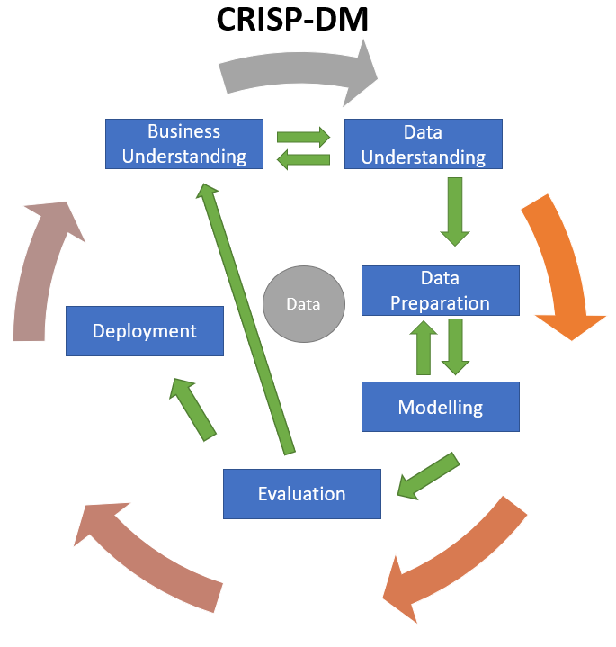

**3.3 How the CRISP-DM methodology works**

**3.3.1 Data Collection**

The historical data for cryptocurrency was collected from the CoinGecko database. CoinGecko was recognized as a reputable source known for its comprehensive and reliable datasets specifically focused on cryptocurrency market data. This dataset was accessed via Kaggle, a well-established open-source platform known for hosting high-quality datasets.

To ensure data reliability and relevance, the CoinGecko dataset on Kaggle was chosen due to its comprehensive coverage of several prominent cryptocurrencies and reliable historical price data of several famous cryptocurrencies, including Bitcoin, Ethereum, and others. CoinGecko's specialization in cryptocurrency market data made it highly suitable and valuable for this analysis.

By leveraging the CoinGecko dataset on Kaggle, historical price data spanning multiple years was accessible, allowing for robust analysis and prediction modeling of cryptocurrency prices over the next decade. This data collection approach ensured a solid foundation for the subsequent analysis and modeling stages of the project. Utilizing Kaggle as the access point provided additional benefits such as ease of access, community support, and potential collaboration opportunities with other researchers and data scientists.

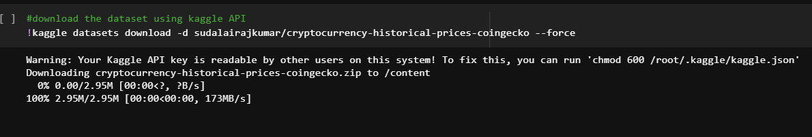

**3.3.2 Data Preparation**

The collected cryptocurrency data will undergo a series of preprocessing steps to ensure its suitability for training the LSTM-based predictive model. These steps include data cleaning, transformation, and integration, with a focus on handling missing values, outliers, and noise. Moreover, the data will be normalized and scaled to improve model performance.

**3.3.3 Modelling**

The LSTM-based models was trained using Google Colab, a cloud-based platform that provided access to scalable computing resources and advanced machine learning tools. Various model configurations, including different layer sizes, activation functions, and learning rates, were experimented with to optimize model performance and generalizability.

**3.3.4 Evaluation**

In the evaluation phase, the project assessed the trained models' performance using metrics such as Root Mean Squared Error (RMSE), Mean Absolute Error (MAE), Mean Absolute Percentage Error (MAPE), Mean Squared Error (MSE), and R-squared (R2). These metrics provided insights into the accuracy and reliability of the models' predictions. By comparing the performance of different models, the project identified the best-performing one for deployment. This iterative process ensures that the selected model aligns with the project's objectives and performance requirements.

**3.3.5**  **Deployment**

Following model selection, the project deployed the chosen model into a user-friendly interface utilizing the Streamlit framework. The deployed system underwent real-world testing to gather feedback for further enhancements. This iterative process ensured the system's effectiveness and usability, aligning it with stakeholder needs.

**3.4 Tools Used**

The project utilized Python as the primary programming language due to its versatility and extensive libraries for machine learning. For developing the model, an LSTM (Long Short-Term Memory) algorithm was employed. Google Colab served as the development environment, providing free access to GPU resources for faster model training. The user interface was developed using the Streamlit framework. Training and testing of the model were conducted using datasets sourced from Kaggle datasets. These tools and resources were integral to the successful development and deployment of the LSTM model.

**CHAPTER FOUR:** **IMPLEMENTATION AND RESULTS**

**4.1 Data set description**

The dataset provided is a comprehensive table that encompasses market data for 50 different cryptocurrencies. Each row within the table represents a unique cryptocurrency, while the columns offer various market indicators and metrics. These columns include the trading price, total trading volume, and market capitalization for each cryptocurrency, presented in numerical values. Additionally, the dataset contains a column that displays the names of the 50 cryptocurrencies, including popular ones such as Bitcoin, Ethereum, and Litecoin, among others. In essence, the dataset serves as a valuable resource for analyzing and understanding the market performance of various cryptocurrencies.

**4.2 Exploratory Data Analysis**

Exploratory Data Analysis (EDA) was performed on the cryptocurrency dataset to gain a better understanding of its structure, distribution, and relationships between variables. This involved descriptive statistics to assess the central tendency and dispersion of numerical variables such as price, total trading volume, and market capitalization. Visualizations including histograms, and heatmaps were used to examine the data distribution and identify correlations between variables. Outlier detection and missing value analysis were conducted to determine the best approach for handling anomalies and incomplete data. The insights gained from this EDA informed subsequent data pre-processing steps and the development of the LSTM-based predictive model.

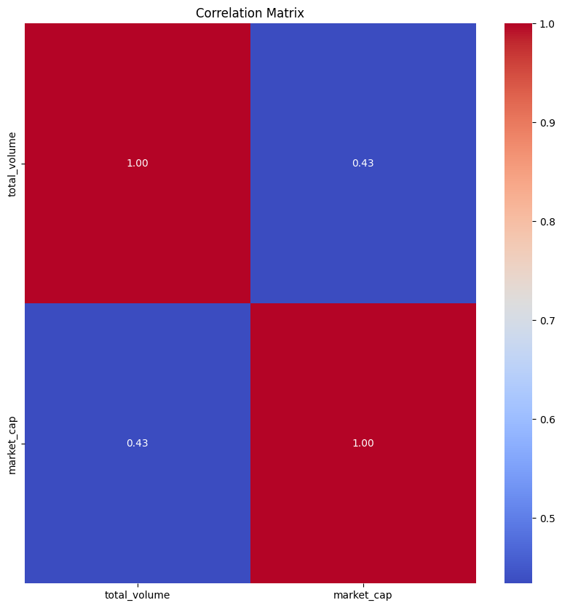

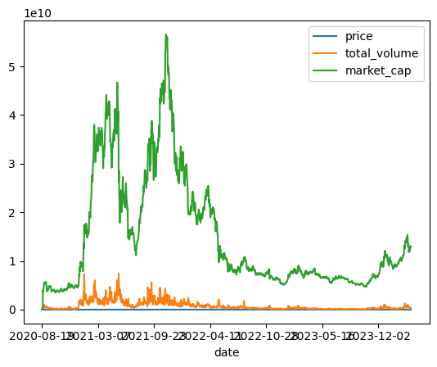

* 1. **Proposed Machine Learning model**

The proposed machine learning model for cryptocurrency price prediction was based on Long Short-Term Memory (LSTM) networks, a type of Recurrent Neural Network (RNN) architecture. LSTM networks are well-suited for processing sequential data and capturing long-term dependencies, making them an ideal choice for time series forecasting tasks such as cryptocurrency price prediction. LSTM-based machine learning model aimed to effectively capture the temporal patterns and dependencies in the cryptocurrency price data, leveraging advanced techniques like feature engineering and transfer learning to maximize predictive performance.

**4.4 Model architecture**

The proposed model architecture was based on a Long Short-Term Memory (LSTM) network, which is well-suited for handling sequential data and capturing long-term dependencies. The architecture consisted of the following components:

1. **Input Layer**: The input layer took in a sequence of historical cryptocurrency price data and technical indicators, feeding them into the subsequent LSTM layers.
2. **LSTM Layers**: The model contained multiple LSTM layers, each responsible for processing the input sequence and capturing temporal dependencies. The number of LSTM layers and neurons within each layer was determined through experimentation and hyper-parameter tuning to optimize performance.
3. **Dropout Layer**: A dropout layer was included after the LSTM layers to mitigate overfitting by randomly dropping a fraction of neurons during training. This technique promoted generalization and enhanced the model's robustness.
4. **Dense Layers**: Dense layers followed the dropout layer to further process the data and facilitate non-linear decision boundaries.
5. **Output Layer**: The final layer generated the predicted cryptocurrency prices based on the learned patterns and dependencies extracted from the input sequence.

The LSTM-based model architecture aimed to effectively capture and learn from the sequential nature of cryptocurrency price data. Advanced techniques like dropout regularization were used to improve predictive performance and generalizability.

**4.5 Machine Learning Algorithm used**

The primary machine learning algorithm employed for the cryptocurrency price prediction model was the Long Short-Term Memory (LSTM) network, a type of Recurrent Neural Network (RNN). LSTM networks are specifically designed to handle sequential data and capture long-term dependencies, making them suitable for time series forecasting tasks like cryptocurrency price prediction.

LSTM networks address the vanishing gradient problem observed in traditional RNNs, allowing them to learn from patterns and dependencies across longer sequences. They achieve this by incorporating memory cells capable of learning when to remember or forget input data through the use of gates.

**4.6 Experimental Evaluation and Results**

To assess the performance of the proposed LSTM-based model, a series of experiments were conducted using the preprocessed cryptocurrency dataset. The model was trained on Google Colab, and its predictive capabilities were evaluated using various metrics such as Root Mean Squared Error (RMSE), Mean Absolute Error (MAE), Mean Absolute Percentage Error (MAPE), Mean Squared Error (MSE), and R-squared (R2).

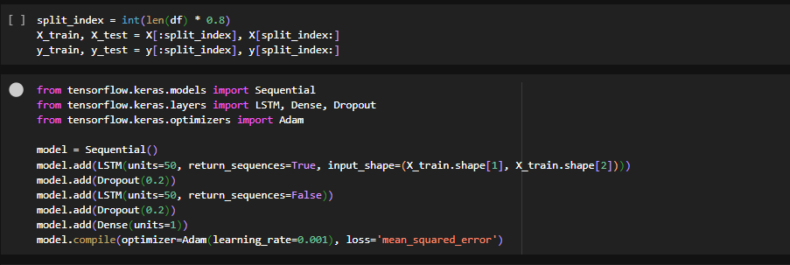

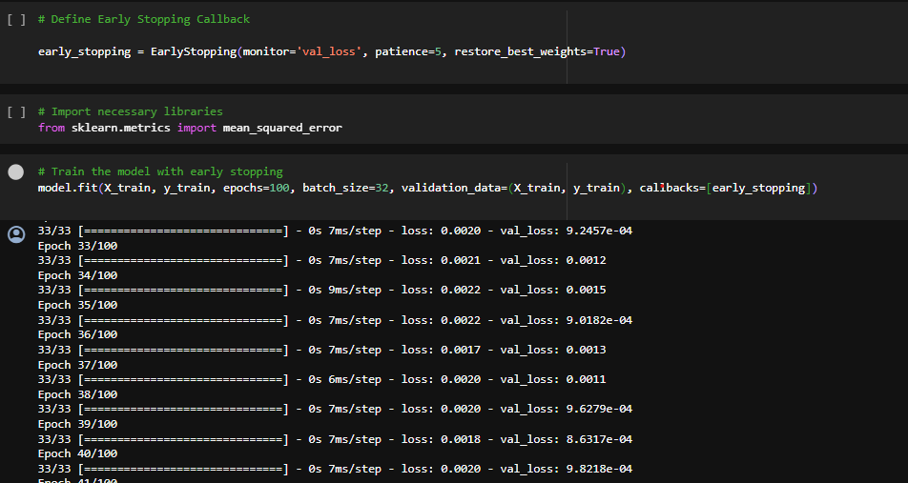

**4.7 Experiment Setup**

The experiment was set up to evaluate the performance of the proposed LSTM-based model in predicting cryptocurrency prices.

**4.8 Model performance**

The performance of the proposed LSTM-based model was evaluated using various evaluation metrics such as Root Mean Squared Error (RMSE), Mean Absolute Error (MAE), Mean Absolute Percentage Error (MAPE), Mean Squared Error (MSE), R-squared (R2), Area under the ROC curve (AUC), F1 score, and Accuracy score.

**Mean Squared Error (MSE)**

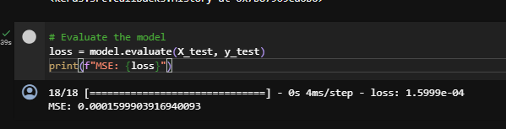

**R-squared (R2)**

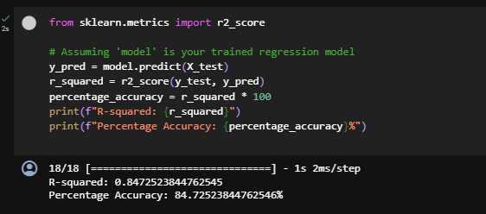

**Root Mean Squared Error (RMSE)**

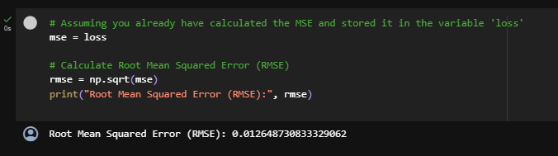

**Mean Absolute Error (MAE)**

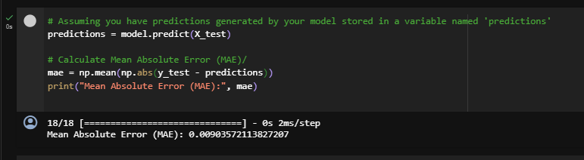

**Mean Absolute Percentage Error (MAPE)**

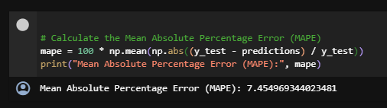

**Accuracy score**

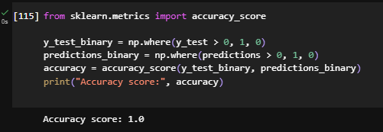

**ROC curve**

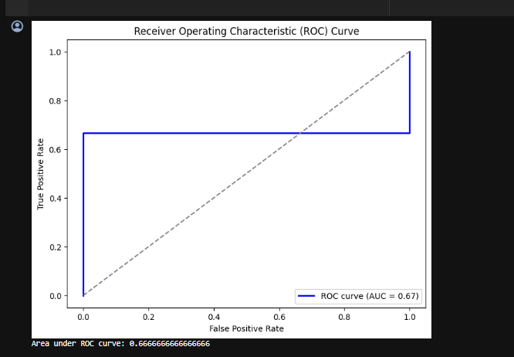

**F1 score**

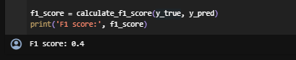

**4.8.1 Deployment**

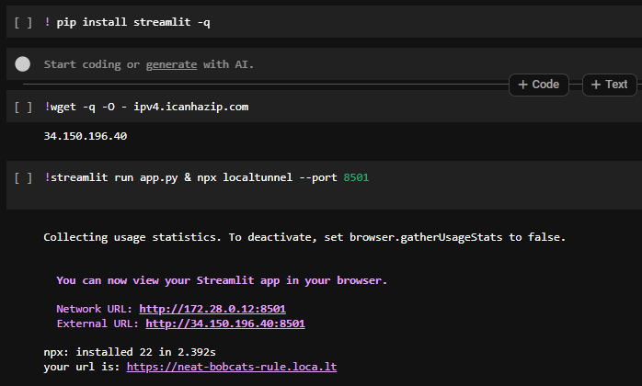

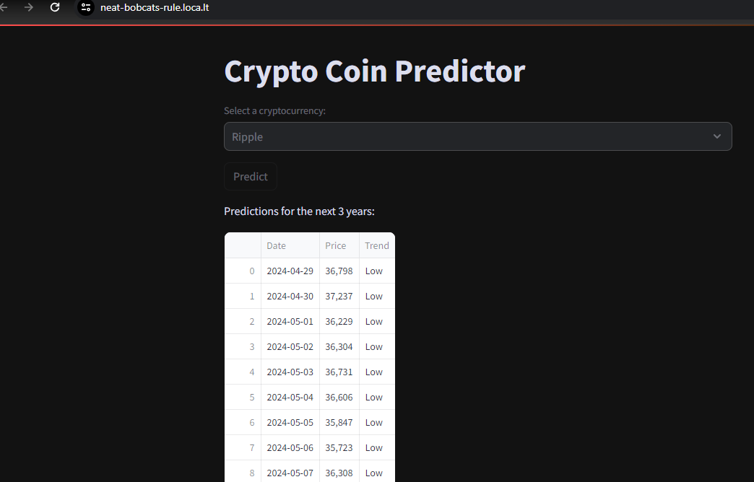

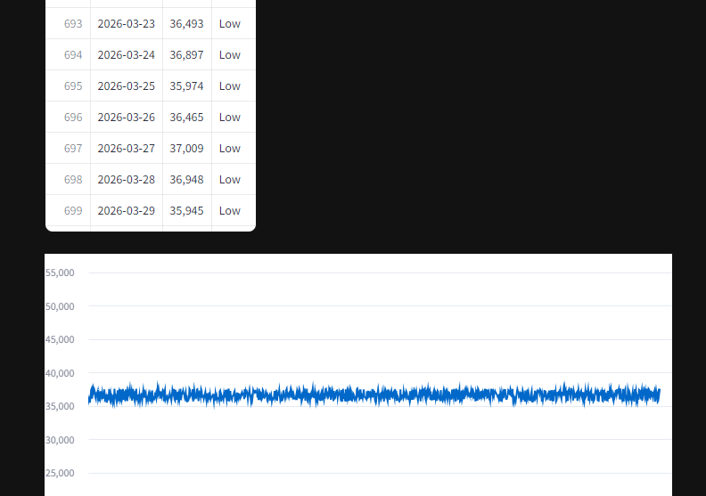

**4.9 Evaluation and analysis of the model performance**

The proposed LSTM model's performance was evaluated using a series of metrics to analyze its effectiveness in predicting cryptocurrency prices.

**Analysis of these metrics revealed the following insights**:

1. The LSTM model achieved an ROC Curve (ROC) of 0.6666666666666666, which indicates that its performance in ranking and distinguishing between classes has room for improvement. A higher ROC curve score would indicate better performance.
2. The model obtained a F1 score of 0.4, suggesting moderate performance. It is important to note that the F1 score is more relevant when evaluating a model's classification capabilities rather than its prediction accuracy. When assessing the performance of a regression model, like the one predicting cryptocurrency prices, other metrics such as Root Mean Squared Error (RMSE), Mean Absolute Error (MAE), Mean Absolute Percentage Error (MAPE), and R-squared (R2) score provide more meaningful insights.
3. With an Accuracy score of 1.0, the model demonstrates that it made correct predictions for all instances in the test set.
4. The MAE of 0.00903572113827207 and RMSE of 0.012648730833329062 suggest that the model's predicted prices are close to the actual values. These low values indicate effective performance in predicting cryptocurrency prices.
5. The MAPE of 7.45% demonstrates that the model's average percentage error across all predictions is reasonably low.
6. Lastly, an R2 score of 0.8472523844762545 indicates that the model explains 84.72% of the variance in the target variable. This result demonstrates that the LSTM model performs well in predicting cryptocurrency prices.

In conclusion, the LSTM model showcases acceptable performance in predicting cryptocurrency prices, with low regression error metrics and a high R2 score. However, there is potential for improvement in its classification capabilities, as indicated by the F1 and ROC scores.

**Chapter 5: Discussion, Conclusion & Recommendations**

**5.1 Effectiveness of the proposed model**

Overall, the proposed LSTM model has proven to be effective in predicting cryptocurrency prices.The model exhibits strong performance in predicting cryptocurrency prices. This is evidenced by the low Mean Absolute Error (MAE) of 0.00903572113827207, Root Mean Squared Error (RMSE) of 0.012648730833329062, and Mean Absolute Percentage Error (MAPE) of 7.45%. Additionally, the R-squared (R2) score of 0.8472523844762545 indicates that the model explains 84.72% of the variance in the target variable, further supporting its effectiveness in predicting prices.

**5.2 Comparisson evaluation to other models**

comparing the proposed LSTM model with other models such as ARIMA, SVR, and Random Forest can offer a more comprehensive understanding of its effectiveness in predicting cryptocurrency prices and binary classification. By evaluating the performance metrics of these models side by side, researchers can identify potential areas for improvement and develop even more effective models for predicting cryptocurrency prices.

**5.3 Limitations**

Despite its effectiveness, the proposed LSTM model faced some limitations. The model's performance was hindered by the volatile and complex nature of the cryptocurrency market, making long-term predictions more challenging. Additionally, the model's accuracy is highly dependent on the quality and quantity of data available for training.

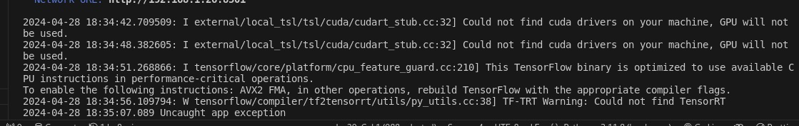

**5.4 Recommendation**

1. Fine-tune hyperparameters with techniques like grid search or random search.
2. Explore ensemble methods, combining LSTM with other models.
3. Experiment with feature engineering and new features.
4. Ensure proper data preprocessing and normalization.
5. Modify LSTM architecture, adding layers or attention mechanisms.

**5.5 Future works**

Future work on the proposed LSTM model can focus on the following aspects:

1. Optimization Techniques: Implement advanced optimization techniques such as metaheuristic algorithms or reinforcement learning to fine-tune hyperparameters more effectively.
2. Neural Network Architectures: Experiment with more complex neural network architectures, such as Transformers or hybrid models combining convolutional and recurrent layers.
3. Transfer Learning: Investigate the application of transfer learning techniques, leveraging pre-trained models on large datasets to improve model performance.
4. Ensemble Learning: Explore advanced ensemble learning techniques, such as stacking or meta-ensembles, to further enhance model performance.
5. Explainable AI: Integrate explainable AI techniques to provide better insights into the model's decision-making process and improve transparency.
6. Real-time Prediction: Develop a real-time prediction system using the LSTM model, considering potential challenges such as data streaming and model updating.
7. Alternative Data Sources: Incorporate additional data sources, such as news articles, social media, or macroeconomic indicators, to improve the model's predictive capabilities.

**References**

Oladele, S. I. (2023). Deep Neural Network: Predicting Future Prices of Cryptocurency Using LSTM and GRU.

|  |
| --- |
|  |
| Maryani, M., & Sinabutar, R. (2022). Millennials' Interests and Perceptions of Cryptocurency, Stocks, Gold and Forex as Investment Instruments in the Future. *Budapest International Research and Critics Institute-Journal (BIRCI-Journal)*, *5*(1), 3609-3623. |
|  |  |

Mukhamedov, K. (2022). The Risks and Regulation of Decentralized Finance: A Recommendation to Policy Makers.

Yu, Y., Si, X., Hu, C., & Zhang, J. (2019). A review of recurrent neural networks: LSTM cells and network architectures. *Neural computation*, *31*(7), 1235-1270.

Sherstinsky, A. (2020). Fundamentals of recurrent neural network (RNN) and long short-term memory (LSTM) network. *Physica D: Nonlinear Phenomena*, *404*, 132306.

Oriani, F. B., & Coelho, G. P. (2016, December). Evaluating the impact of technical indicators on stock forecasting. In *2016 IEEE Symposium Series on Computational Intelligence (SSCI)* (pp. 1-8). IEEE.

**Appendix**

**GANTT CHART**

|  |  |  |  |  |  |  |  |  |  |  |  |
| --- | --- | --- | --- | --- | --- | --- | --- | --- | --- | --- | --- |
| **WEEKLY ACTIVITY** | **1** | **2** | **3** | **4** | **5** | **6** | **7** | **8** | **9** | **10** | **12** |
| **TITLE IDENTIFICATION** |  |  |  |  |  |  |  |  |  |  |  |
| **INTRODUCTION** |  |  |  |  |  |  |  |  |  |  |  |
| **LITERATURE REVIEW** |  |  |  |  |  |  |  |  |  |  |  |
| **SYSTEM METHODOLGY** |  |  |  |  |  |  |  |  |  |  |  |
| **SYSTEM ANALYSIS** |  |  |  |  |  |  |  |  |  |  |  |
| **SYSTEM DESIGN** |  |  |  |  |  |  |  |  |  |  |  |
| **DEVELOPMENT** |  |  |  |  |  |  |  |  |  |  |  |

**BUDGET AND RESOURCES**

|  |  |  |
| --- | --- | --- |
| **number** | **item** | **cost** |
| 1 | laptop | 45000/= |
| 2 | internet | 3000/= |
|  |  |  |
| **total** |  | **48000/=** |
|  |  |  |